**Project Planning Phase**

**Project Planning Template (Product Backlog, Sprint Planning, Stories, Story points)**

|  |  |
| --- | --- |
| Date | 18 October 2022 |
| Team ID | PNT2022TMID10261 |
| Project Name | Project - Personal Assistance for Seniors who are Self- Reliant |
| Maximum Marks | 8 Marks |

**Product Backlog, Sprint Schedule, and Estimation (4 Marks)**

|  |  |  |  |  |  |  |
| --- | --- | --- | --- | --- | --- | --- |
| **Sprint** | **Functional**  **Requirement (Epic)** | **User Story**  **Number** | **User Story / Task** | **Story Points** | **Priority** | **Team**  **Members** |
| Sprint-1 | Registration | USN-1 | As a user, I can register for the application by entering my email or mobile number, password, and confirming my password. | 2 | High | Jayaram  Akash  Arunagiri  Afsal |
| Sprint-1 |  | USN-2 | As a user, I will receive confirmation email once  I have registered for the application | 1 | High | Jayaram  Akash  Arunagiri  Afsal |
| Sprint-1 |  | USN-3 | As a user, I can register for the application through Gmail | 2 | medium | Jayaram  Akash  Arunagiri  Afsal |
| Sprint-1 |  | USN-4 | As a user, I can log into the application by entering email or mobile number & password | 2 | High | Jayaram  Akash  Arunagiri  Afsal |
| Sprint-2 | Login | USN-5 | As a user, I can update my reminders and medicines wherever required | 1 | High | Jayaram  Akash  Arunagiri  Afsal |
| Sprint-2 | Dashboard | USN-6 | As a user, I can check the application whether the medicine dosage is completed | 1 | Medium | Jayaram  Akash  Arunagiri  Afsal |
|  |  | USN-7 | For any troubleshooting, the user can send a mail to the technical team | 1 | Low | Jayaram  Akash  Arunagiri  Afsal |
| Sprint-3 |  | USN-8 | Ensures smooth functioning and data warehousing strategies | 1 | Medium | Jayaram  Akash  Arunagiri  Afsal |

**Project Tracker, Velocity & Burndown Chart: (4 Marks)**

|  |  |  |  |  |  |  |
| --- | --- | --- | --- | --- | --- | --- |
| **Sprint** | **Total Story Points** | **Duration** | **Sprint Start Date** | **Sprint End Date (Planned)** | **Story Points**  **Completed (as on**  **Planned End Date)** | **Sprint Release Date (Actual)** |
| Sprint-1 | 20 | 10 Days | 24 Oct 2022 | 03 Nov 2022 | 20 | 03 Nov 2022 |
| Sprint-2 | 20 | 5 Days | 4 Nov 2022 | 09 Nov 2022 | 20 | 09 Nov 2022 |
| Sprint-3 | 20 | 5 Days | 10 Nov 2022 | 15 Nov 2022 | 20 | 15 Nov 2022 |
| Sprint-4 | 20 | 2 Days | 16 Nov 2022 | 17 Nov 2022 | 20 | 17 Nov 2022 |

**Velocity:**

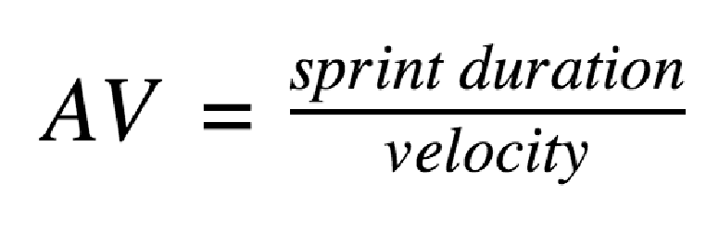

For Sprint-1, AV=20/10=2

For Sprint-2, AV=20/5=4

For Sprint-3, AV=20/5=4

For Sprint-4, AV=20/2=10

**Burndown Chart:**

